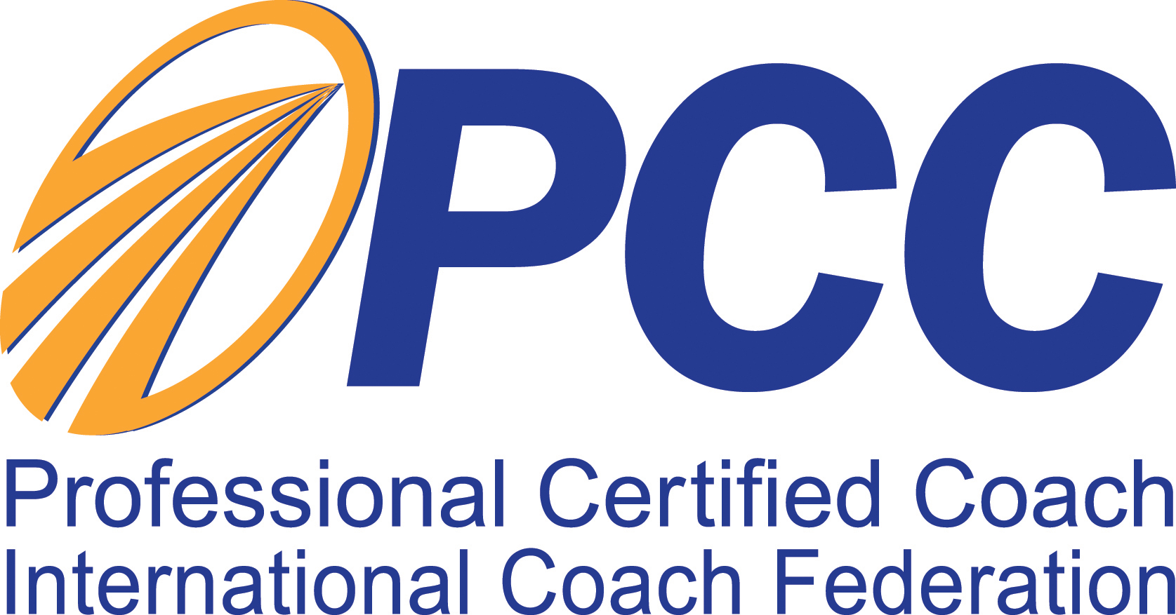
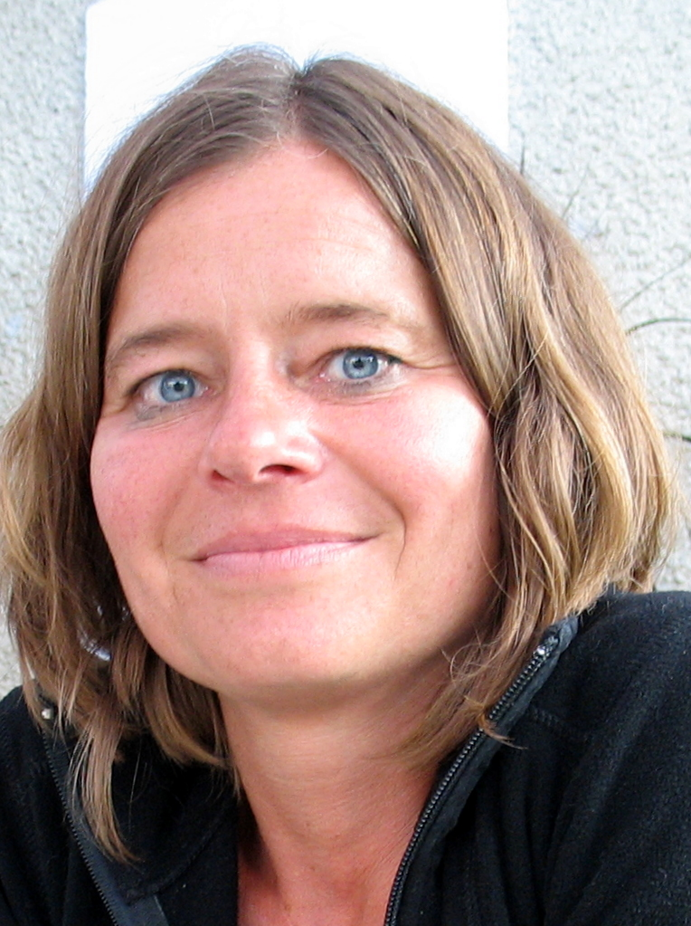
MAGDALENA KULICKA

Coaching Human Capital
Mobile: +48 602 733 861
magdalena@chc.kulicka.pl
www.chc.kulicka.pl
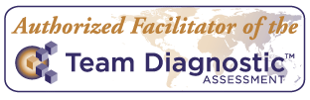
Professional Certified Coach
Certified Professional Co-Active Coach
Organizational Relationship Systems Coach
Senior Consultant, Trainer

EDUCATION
- Master’s Degree in Psychology, Faculty of Psychology, University of Warsaw (1990)
- Professional Certified Coach – accredited by International Coach Federation (June, 2011)
- Certified Professional Co-Active Coach (July1, 2008) – completed course of The Coaches Training Institute, school accredited by the International Coach Federation.
- Authorized Facilitator of the Team Diagnostic Assesment, led by Team Coaching International, course accredited by International Coach Federation (2010).
- Organization & Relationship Systems Coach, led by Center for Right Relationship, school accredited by the International Coach Federation (2009).
- Taming Your Gremlin® - workshop led by Ricka Carsona
- Gateway for Leadership – completed course for developing coaching skills for leaders and managers (2006).
PROFESSIONAL EXPERIENCE
- Coach, Senior Consultant, Trainer, Coaching Human Capital, since 2009
- Coach, Senior Consultant, Trainer, Managing Partner, Human Capital Group 2003 – 2009
- Director of Human Resources Department, Masterlink Express Ltd. part of Sweden Post (3 years)
- Senior Consultant, Co-owner, Yes-Consensus Sp. z o.o. (4 years)
- Academic Teacher and Ph.D. student, Department of Social Psychology, Faculty of Psychology, University of Warsaw

KEY COMPETENCES & EXPERIENCES

COACHING
Co-Active Coaching
- Types of coaching: business coaching - executive coaching, managerial coaching and life coaching
- 64 clients (25 executives, 26 middle management, 11 life coaching, 1 mentor coaching)
- More than 909 contracted individual coaching hours
- Coaching provided for clients from: Wojewódzki Urząd Mazowiecki, Accenture, Orlen Upstream, Sony Poland, The Office of Electronic Communication, Johnson&Johnson, AXA Życie Towarzystwo Ubezpieczeń, Cadbury Wedel, Danone, Gaspol, Rockwool, Bayer, Vattenfall, Microsoft, Avon Cosmetics, Hamamatsu

Team Coaching
- 10 clients for team coaching
- 171 contracted team coaching hours
- Coaching provided for: DM BZ WBK, Ipsen Road Logistic, Ipsen Logistic, Acxiom, Accenture, AXA Życie Towarzystwo Ubezpieczeń, The Office of Electronic Communication, NASK

Workshops for the board of directors
Strategic action planning workshop for top executives in co-operation with the Great Place To Work – Novo Nordisk Pharma, Real, Coca-Cola HBC, Urząd Lotnictwa Cywilnego, Wedel

TRAINING
Creating programs and providing training or workshop:
- Effective organizational communication workshop - ProLog
- Facilitation of development of internal cooperation rules – TelePizza
- Managerial skills development – TP SA, City Bank, Coca-Cola HBC Polska, Vos Logistics, Wincanton Trans European, Masterlink Express, ProLog (EastExpress), TelePizza
- Effective coaching – Coca-Cola HBC Polska, ZPC Mieszko S.A.
- The art of Negotiating – ZPC Mieszko S.A., Poczta Polska, Masterlink Express, Herbapol, Polanglo, ITP, Międzynarodowa Szkoła Menedżerów, MBA course on Warsaw Technical School
- Mediation and Conflict Resolution – Commercial Union S.A.
- Effective Selling – Bosch (BSH), ITP, General Motors – Opel, Polanglo, Wincanton Trans European
- Customer service – ZPC Mieszko S.A., Fundacja Leonardo da Vinci, Masterlink Express, ORFE, P&O Wincanton Trans European, ProLog (EastExpress), Masterlink Express
- Presentation techniques – Tramwaje Warszawskie, Polanglo, Fundacja Leonardo da Vinci
- Assessor skills, training for internal assessors – Danone, BZ WBK
- Assertive behaviors – City Bank
- Communication Skills – City Bank
CONSULTING
- Managerial audits, AC/DC programs, individual diagnostic-consulting programs – Tetley, BZ WBK, Agora S.A., PZU S.A., Orbis S.A., Carlsberg, CDM Pekao, Bank Pekao S.A., Bank BPH S.A., Rockwool, Danone, LU Polska
    - 165 hourse of feedback sessions for Development Center participants (115 people)
- Feedback information consulting for subordinates after 360º evaluation – DM BZ WBK (4 people – top executives)
- Outplacement program, 6 people, Cadbury - Wedel
- Recruitment methodology design and execution of recruitment programs – Danone, ProLog (EastExpress), Expander
- Change management, organizational culture diagnosis and design - ProLog (EastExpress)
- Designing and implementing appraisal systems – Orfe S.A., Masterlink Express
- Service reception audit – Top Car

LINES OF BUSINESS
FMCG, Financial, Pharmacia, IT, Logistic, Services, Insurance, Higher Education, Consulting
Membership in Professional Assosiations
- International Coach Federation, member
- Co-Active Coach Association, board member, entrepreneurial

